Ohm

**STA 5207: Homework 1**

**Exercise 1 (Exploratory Data Analysis (EDA) for Diabetes Data)**

For this exercise, we will use the diabetes dataset from the faraway package, which is the package for the recommend textbook for this course Linear Models with R by Julian J. Faraway.

1.Install and load the faraway package. Do not include the installation command in your .Rmd file. (If you, do it will install the package every time you knit your file.). Do include the command to load the package into your environment in an R chunk that is not executed as you answer to this question below.

***Answer:***

This exercise will be conducted using the **"diabetes"** dataset from the "faraway" package. To access and work with this dataset in R, you must import the "**faraway**" package into your R environment. By running the command **install.packages('faraway')**, you can install this package if you haven't already. Packages in R are like extensions or plugins that enhance the functionality of the base R software. They are essentially collections of software components developed by various contributors, designed to provide additional capabilities and tools for data analysis, visualization, and more.

The package doesn't need to be installed again after the first time. However, you must load it into your existing R environment using **library(faraway**) in order to use its features and functionalities. This gives you the skills required for thorough data analysis activities and makes the package's resources available for various data-related operations within the current R session.

2.How many observations are in the diabetes dataset? How many variables? Who are the individuals in this dataset?

***Answer:***

Using the **str** function in R, it is possible to calculate how many observations, variables, and individuals the diabetes dataset contains. Upon execution of this command, a summary of the diabetes dataset's structure will appear, including details about observations, variables, and data types.

* The diabetes dataset contains a total of **403** observations. You can also check with **nrow(diabetes)** command.
* The diabetes dataset comprises **19** variables. You can also check with **ncol(diabetes)** command.

**dim(diabetes)** will give both observation and variable count.

* This dataset includes the data of individuals who were part of a study aimed at determining the prevalence of diabetes, obesity, and other cardiovascular risk factors in Central Virginia. Despite the fact that the collection primarily relates to African Americans, neither individual identities nor demographic characteristics are provided directly.

3.How many individuals have HDL levels (High Density Lipoprotein) that are missing, that is, have a value of NA? What are the row numbers of the missing individuals? What is the mean HDL level (High Density Lipoprotein) of individuals in this sample?

Hint: The mean should be calculated with NA values removed. Use? mean to determine an argument that removes missing values before calculating the mean.

Answer:

* **The total number individuals that have a NA value is 1**

Use the **is.na ()** function to determine how many people in the diabetes dataset lack HDL (High Density Lipoprotein) values. Each HDL value in the dataset is checked by this function, which then produces a list of **TRUE or FALSE** values, where TRUE denotes missing data (NA) and FALSE, valid data. The overall count of missing HDL values can be determined by applying the **sum ()** function to this list, which will provide you with the total number of NA in the dataset.

* **The 28th row number which is Na is returned by the which () function.**

Use the which () method in conjunction with the is.na () function to get the row numbers of the individuals who are missing and have NA values in the "HDL" column of the "diabetes" dataset. When the "HDL" level is missing (NA).

* **The mean HDL level of individual in the sample is 50.4452736318408**

There are three ways to determine the mean HDL (High Density Lipoprotein) level in the "diabetes" dataset while omitting missing values (NA):

Setting **na.rm = TRUE** in the mean () function causes this method to calculate the mean without taking NAs into account. It offers a simple method to compute the mean while ignoring missing values, ensuring a trustworthy indicator of mean.

**Specific Rows Can Be Removed**: By removing rows with NA values, such as the 28th row with no HDL data, a new dataset can be created. By using this strategy, theoriginal dataset is maintained and the mean is determined from all available data.

When using **na.omit()**, a fresh dataset is generated without any rows that have missing HDL data. It makes data cleansing easier and ensures that the mean.

4. What is the standard deviation of total cholesterol of individuals in this sample after removing missing values?

Answer:

The standard deviation of total cholesterol in the sample, after removing missing values using

the "na.rm" method, is **44.4455574336558**

5. What is the range of ages of individuals in this sample?

Answer:

The range of ages of individuals in the sample is int [1:2] **19 92**

6. What is the mean HDL of males in this sample?

**The mean HDL of males in the sample 48.125**

1) Using sub setting and the mean() function:

By explicitly filtering the "diabetes" dataset based on gender ("Male") and calculating the mean within this subset, this approach determines the mean HDL levels for guys.

2) Using the select parameter and a data subset:

The mean HDL level is determined inside this isolated dataset by first creating a new dataset ("male_data") that solely contains data from men. This approach provides a methodical manner to analyze data that is special to men.

7. Create a scatter plot of HDL (y-axis) vs weight (x-axis). Use a non-default color for the points. Also, be sure to give the plot a title and label the axes appropriately. Based on the scatter plot, does there seem to be a relationship between the two variables? Briefly explain.

Answer

The Scatter plt of HDL (y-axis) vs weight (x-axis) is

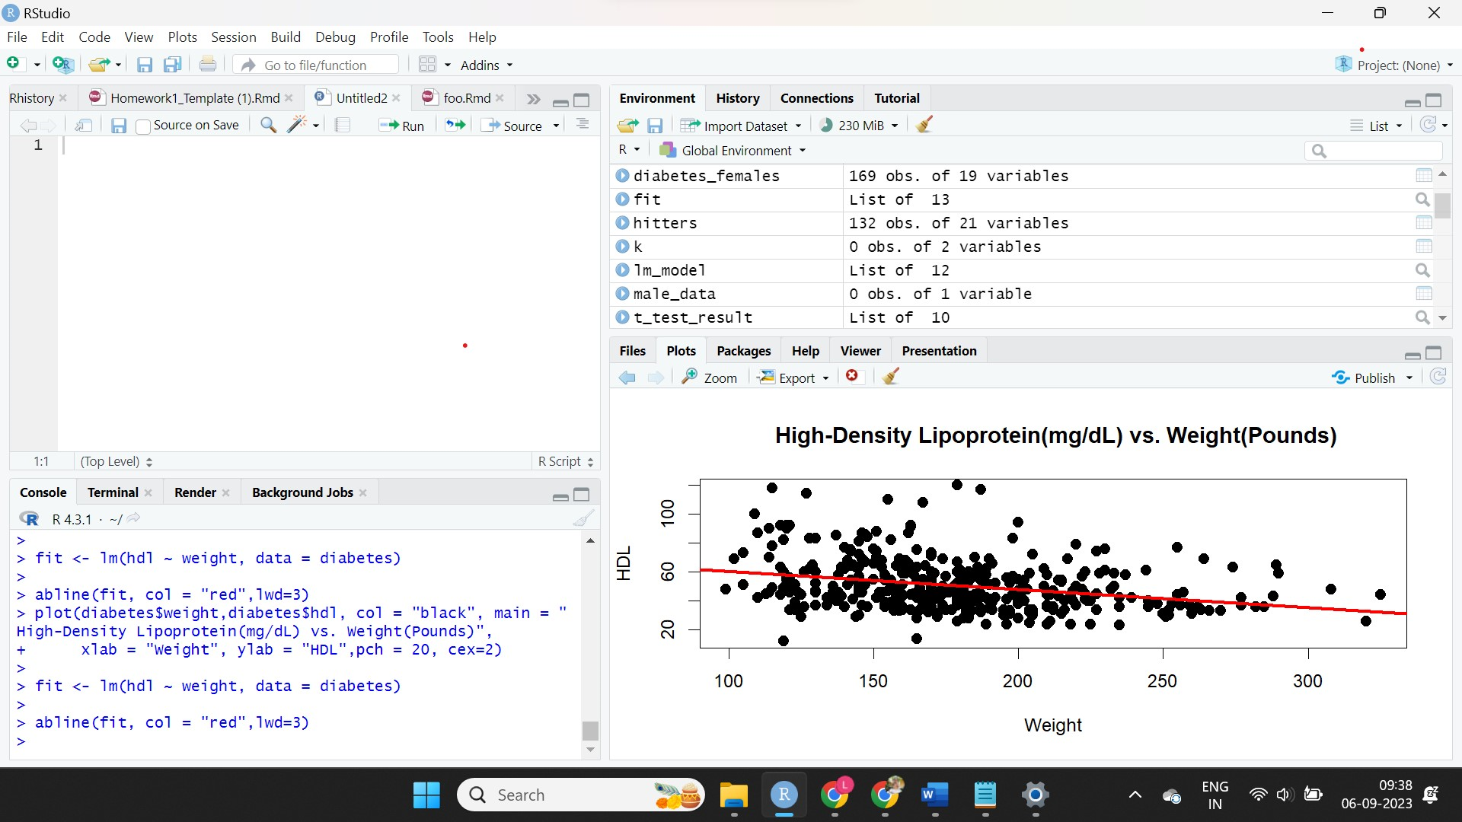

Upon visual examination of the scatter plot, no clear linear trend is evident; data points are scattered, challenging the identification of a pattern. However, it suggests that higher weight corresponds to lower HDL levels, implying a potential negative correlation.

In our Linear Regression Analysis, we quantitatively explored the relationship using the equation:

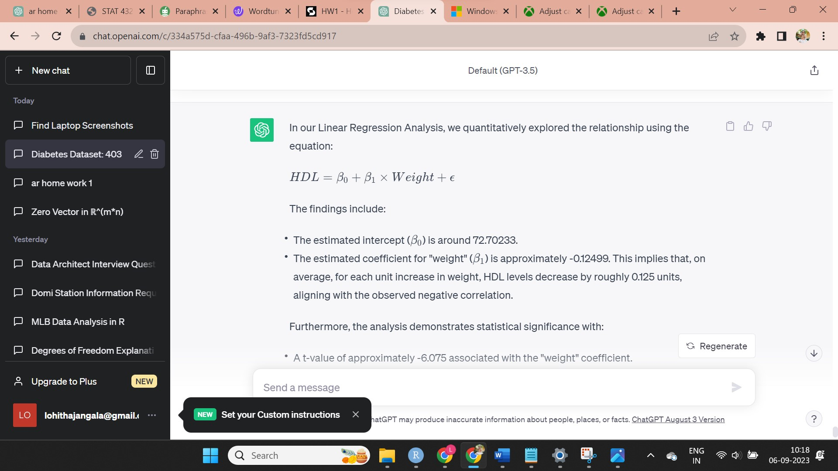

The findings include: The estimated intercept  = 72.70233., slope=-0.12499 implies that, on average, for each unit increase in weight, HDL levels decrease by roughly 0.125 units, the correlation between weight and HDL is about -0.287, indicating a moderate negative correlation. As weight rises, HDL levels tend to decrease, underscoring a noticeable linear association. aligning with the observed negative correlation.

Furthermore, t-value -6.075 associated with the "weight" coefficient. A highly significant p-value of approximately 2.891e-09, indicating strong evidence against the null hypothesis of no relationship support the presence of a significant negative correlation.

8. Create a scatter plot of total cholesterol (y-axis) vs weight (x-axis). Use a non-default color for the points. Also, be sure to give the plot a title and label the axes appropriately. Based on the scatter plot, does there seem to be a relationship between the two variables? Briefly explain.

The scatter plot of total cholesterol (y-axis) vs weight (x-axis)

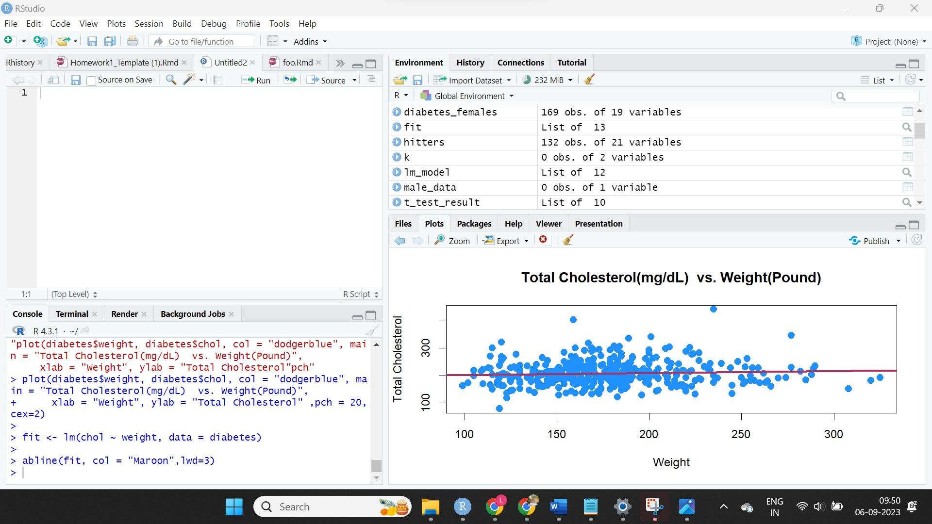

There is no discernible correlation between weight and total cholesterol levels, according to the scatter plot and linear regression. The sloping regression line and random data distribution suggest a very weak or non-existent association. Changes in weight do not reliably predict changes in cholesterol levels.

In our Linear Regression Analysis, we quantitatively explored the relationship using the equation:

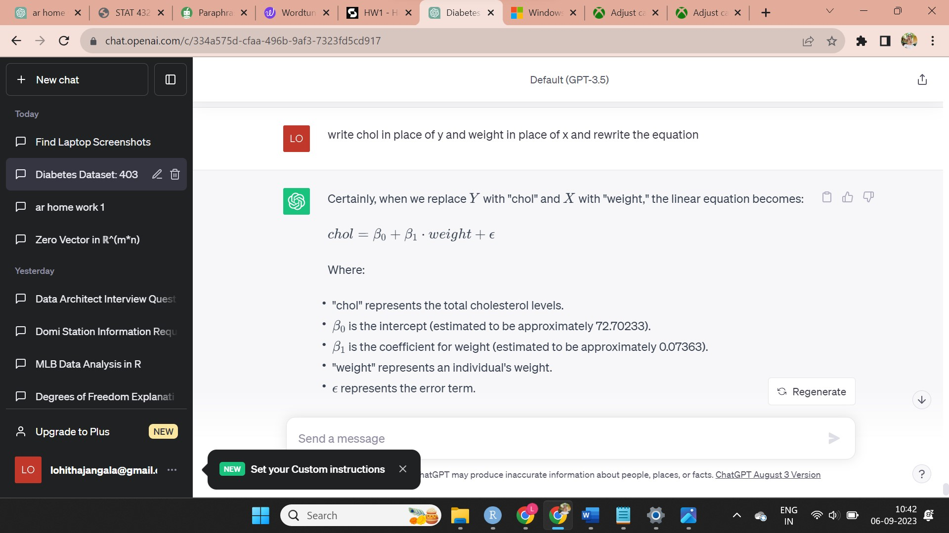

The findings include: The estimated intercept = 194.98642 ., slope= 0.07363This implies that, on average, for each unit increase in weight, total cholesterol levels (chol) increase by roughly 0.07363 units. The correlation between weight and total cholesterol levels (chol) is about 0.066, indicating a very weak and nearly negligible correlation.

The p-value is approximately 0.181, while the t-value for the "weight" coefficient is roughly 1.339. These findings suggest a slight association, but do not offer significant statistical support against the null hypothesis that there is no relationship between weight and total cholesterol levels (chol).

9.Create side-by-side boxplots for HDL by gender. Use non-default colors for the plot. Also, be sure to give the plot a title and label the axes appropriately. Based on the boxplot, does there seem to be a difference between HDL level and gender? Briefly explain

The side-by-side boxplots for HDL by gender

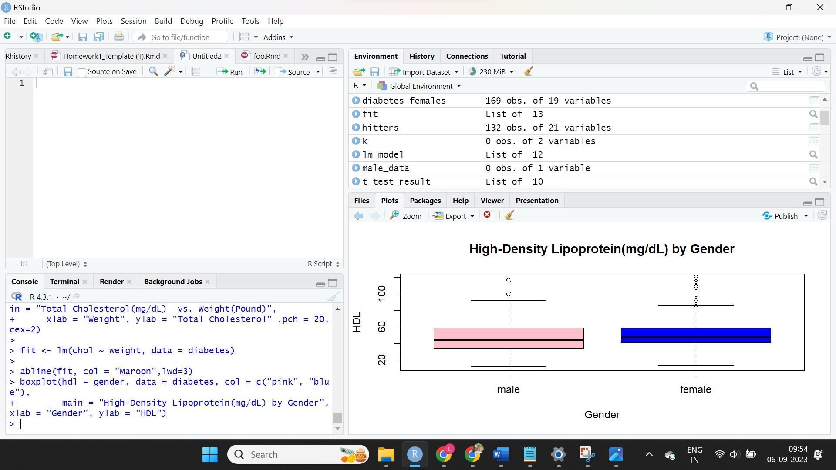

The statistical analysis and the visual review of the boxplot The boxplot findings are well supported statistically by the results of the two-sample t-test. The t-test results show that the mean HDL level for females is considerably greater than that for males, as indicated by the negative t-value (-2.3) and the low p-value (0.02202). The results of the t-test consistently show that the levels of HDL between the sexes differ significantly. Statistics show that females often have greater HDL levels than males, and this difference is statistically significant. The boxplot graphically illustrates this distinction and offers further information about the data distribution.